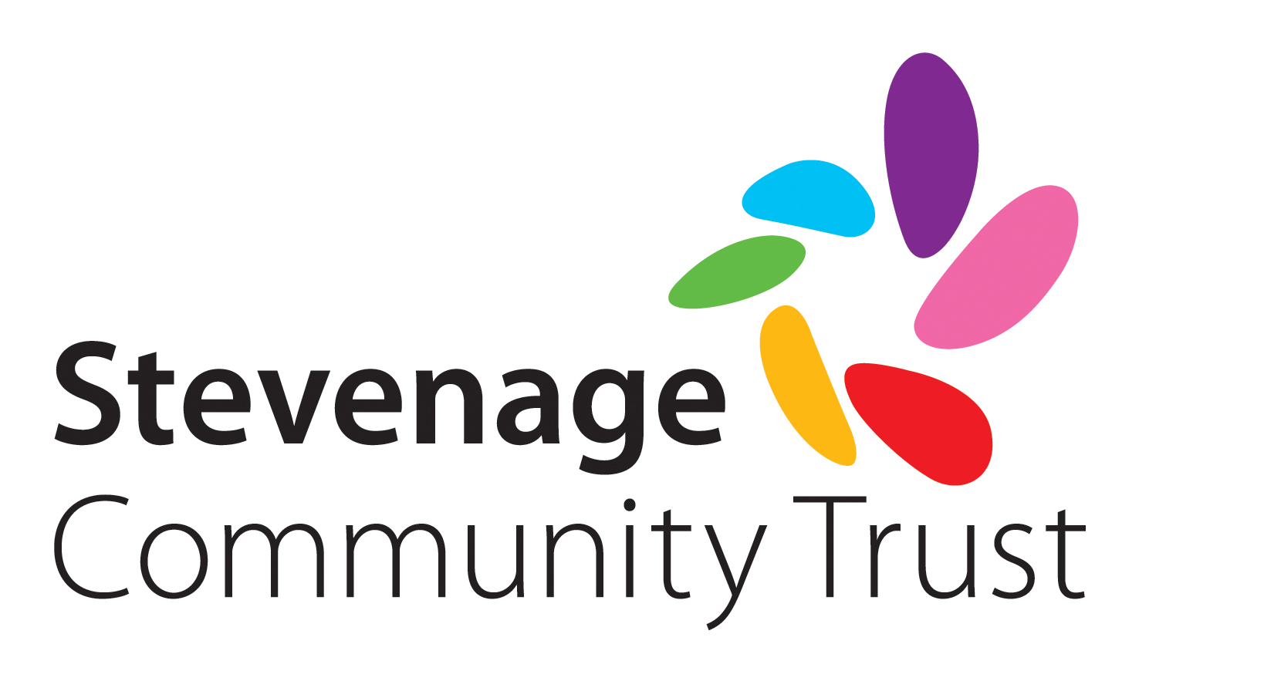
Terms and Conditions

Please read this information carefully

Community Grants

By accepting this grant you agree to:

- Spend the grant entirely for the purpose it was intended. It is advisable to retain receipts of any product or service purchased as they may be subject to future audit.
- Notify the Trust if any balance remains 12 months after the grant was issued or on completion of spend.
- Attend our grant presentation evening and share details of how the funds have benefited your organisation and those you serve.
- Complete and return our monitoring and evaluation form. Failure to return a monitoring form within 6 months or at the end of the project/once equipment has been purchased, whichever is sooner, will affect future funding requests.
- Promote Stevenage Community Trust as described in your funding application and publicly acknowledge the grant in the local press, on your website and via social media wherever possible.
- Our photographer taking photographs in relation to the funding for use in our publicity e.g. website, newsletters, annual report, local press, social media. Please obtain consent in writing from the parent or legal guardian of anyone under the age of 18, prior to the visit. A consent form can be found at http://stevenagecommunitytrust.org/forms

